# **ALC Process and FAQ Documentation**

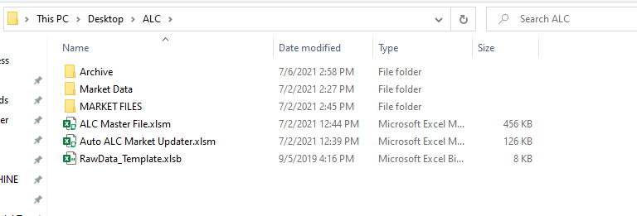

**THE PROCESS:**

Before beginning there are 3 Important things to have in your desktop for ALC auto process to work.

1. Have a folder named “ALC” on your desktop with the following ***subfolders.***   
    - “Market Data” (Raw data dump)  
   - “Market Files” (Where the newly built market ALC files go)
2. 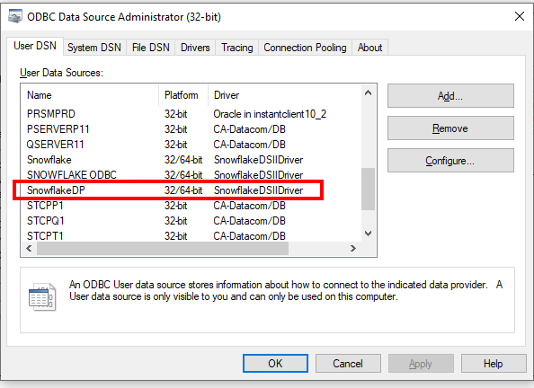Make sure these following ***files*** are in the ALC folder.  
   - “ALC Master File.xlsm” (Master ALC file)  
   - “Auto ALC Market Updater.xlsm” (The master run file)  
   - “RawData_Template.xlsm” (A file that the automation uses to organize the data. Ideally DO NOT TOUCH)
3. Snowflake ODBC – if you do not have this then this process is pretty much as good as dead on your PC. To make sure you have the Snowflake ODBC installed on your PC, call the IT help desk and let them know it’s a PRIORITY to have the Snowflake ODBC for both 32-bit AND 62-bit installed on your PC. (Will they consider it priority and install it quickly? Who knows?)   
   Refer to the screenshot on the right to ensure that you have SnowflakeDSIIDriver installed on your PC.

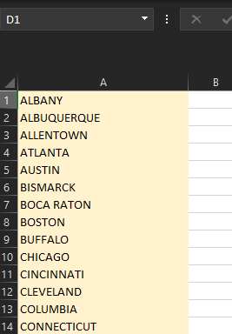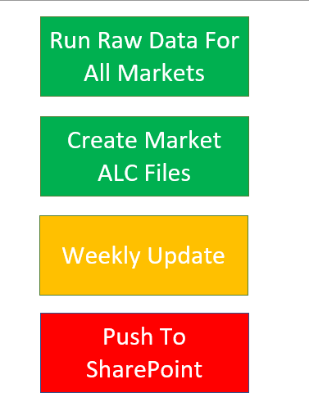  
**Step 1:**  
Once your folders and files are in the right places let’s cover how to create the ALC files on a quarterly and weekly basis.

Go into the Auto ALC Market Updater.

And go to the sheet “Start Here”.

Here is what each button does.

* **Run Raw Data For All Markets** – pulls down all raw data from Snowflake into the Raw Data Template file that you saw in the folder.
* **Create Market ALC Files** – Takes the raw data and adds it into the ALC Master File, then it shapes and molds a brand new and beautiful ALC File!
* **Weekly Update** – Button only needs to be pressed once a week. Updates the modellable customers lists. (You must make sure the Market Files folder has all the ALC files)
* **Push To SharePoint** – will identify the unique folders that each market ALC files have to be placed into.

As much as we LOVE pressing buttons, before we get to pressing any one of these. We must make sure that the market list is correctly updated and pasted in the right column.

Go to sheet “MARKET LIST” and make sure all the markets you want to run on are in Column A (See second image to the right).

**Step 2:**

Once a quarter, click on these 3 buttons.  
“Run Raw Data For All Markets”, “Create Market ALC Files”, and “Push To SharePoint”.

That’s pretty much it. Quarterly.

No image here

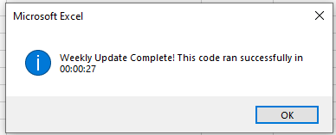**Step 3:**

On a weekly basis, make sure to hit that “Weekly Update” button and then once that’s complete, proceed to click on the “Push To SharePoint” button.

*Note - always look out for the runtime alert at the end of each run to know that the code ran successfully! 😊*

That is pretty much it for running ALC on a quarterly and weekly basis.  
Make sure to double check SharePoint and check to see if everything ran correctly with all the files uploaded correctly as well.

**THE FAQ SECTION:**

Here we are at the FAQ section, I will try my best to come up with FAQ’s on what happened before, and what could happen with some notes on how to fix it! I promise, this will be the best FAQ section you have read in any given process guide. I stake my reputation on it!

Anyways, let’s start.

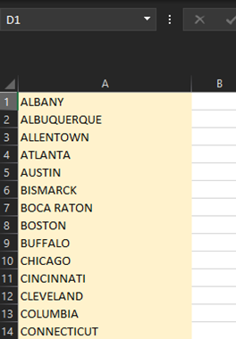

**FAQ #1: Runtime error when I click “Run Raw Data For All Markets” – why is this happening to me?**

Sometimes, for reasons I still have yet to figure out, the automation trips up and even though there is no issues with the file, data, or VB code really – it just…. trips.

The easiest way to diagnose and potentially fix this issue is to just close everything down without saving ANYTHING. Then reopen the Auto ALC Market Updater.

From there just use HALF of the market list and run again. Should run a lot smoother.



**FAQ #2: I want to REMOVE a certain market from the run list. How do I do that?**

Simply, just remove them from the run list in the Market List and it will not run on the market.

As a reminder, whatever markets you enter in column A is what’s ran.

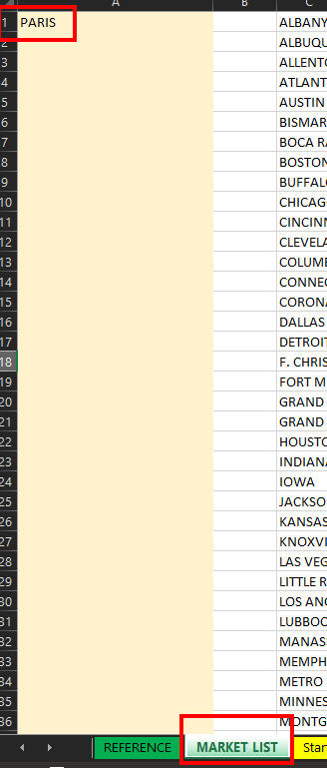

**FAQ #3: Curveball, I want to ADD a NEW market to the run list. How do I do that?**

There are several steps to this.

1. Add the new Location to the Market List. For the sake of example, let’s add the new Market “Paris” (which btw there’s a town called Paris in Kentucky. Lovely people, terrible food)
2. In the second image, make sure to add in the new “Paris” Market so the automation knows what Folder in SharePoint to push it to.  
   If you need to make sure to use the Folder Name Actual column incase the folder name in SharePoint doesn’t match the Market Name from the system. This change is done in the “Push To SharePoint” sheet.
3. 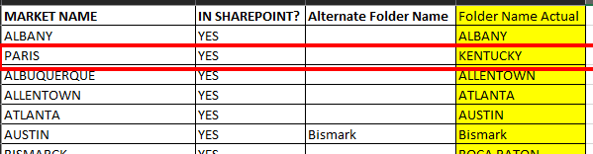Lastly, add the market in the Markets Sheet to make sure the cross references for Market Name and Branch Code are there.  
   (This table is just used for file creation and making sure the right names and references are in place)

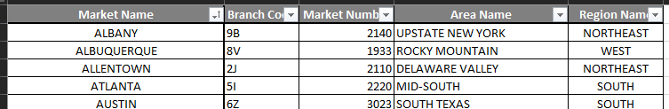

**FAQ #4: The automation run is taking a long time; how do I know it’s not broken, or something went wrong.**

We just have to wait. Yep just wait. Unless you are getting an actual runtime error, let’s the automation due its thing and run. Depending on the speed of your computer it can run for about an hour and 30 minutes even.

Now, if it runs for several hours then something has gone horribly wrong and you should probably stop the automation.

How can you stop it mid-run? Just tap “ESC” repeatedly until the automation just stops. Close everything down without saving it and run it again but this time on fewer list of markets just in case.

**FAQ #5: There’s something still wrong, and ALC files are not being generated.**

Sometimes, when you make updates to the ALC Master file, we hide some sheets that shouldn’t have been hidden. Make sure that all of these sheets (image on the right) should be open. These sheets are where the automation goes in to drop all the data!

